|  |
| --- |
|  |
| Wendigo: Eternal Night |
|  |
|  |
| **Kaitlyn Moeller**    **Image Credit: Dillon Samuelson** |
|  |

Table of Contents

Premise/High Concept 2

Features 2

Target Audience 3

Player Motivation 4

Gameplay Highlights 4

Technology Highlights 5

Art Highlights 6

Game World 7

Mechanics 7

Story Progression 9

Character Descriptions 9

Hunter 9

Wendigo 10

NPC Civilian 10

NPC Military 10

User Interface 11

Platform 12

Project Management 12

Team 12

Budget 13

Schedule 13

# Premise/High Concept

*Wendigo: Eternal Night* is a first-person 3D survival horror game. In a nighttime forest, you play as the wendigo or an expert hunter. Wendigos utilize their heightened senses to detect foes. Hunters must gather resources and survive danger. The player who kills the other wins.

# Features

The game environment is an open world map with pseudo-random structural generation and spawn points. Lakes and trees are natural structures that always remain in the same position. Man-made structures change in frequency and location. Cabins, tents, and items are sparsely placed on the map. After 30 minutes of gameplay, more items spawn in random locations.

Black bears, gray wolves, moose, and whitetail deer are wildlife. Unless the hunter is near a bear too long, bears will not attack. Wolves exhibit the same behavior. Deer are docile but fast at retreat. When any mammal is slain, the hunter can use skin as clothes and meat as nutrition.

Food, water, medical supplies, melee weapons, tools, fire, and traps are collectible items. Berries can be edible or poisonous. Fruits, vegetables, dairy, grains, and meat are obtainable. Water and food can be gathered from natural or man-made sources. Medical supplies are bandages and pain killers. Weapons are looted from structures or crafted from raw materials. Tools are necessary to build and destroy objects. Fire provides light and damages wendigos. Traps affect the wendigo and other animals.

Wendigos customize skill power. Their base traits are 3 times better than hunters. In the beginning, they allocate 8 skill points. Continuous skill utilization improves their power. Their maximum vision, hearing, strength, and speed is 5 times better than hunters. Nevertheless, they cannot use items.

Hunters customize appearance. They can modify their skin, hair, eyes, clothing, and backpack colors. Outfits resemble Sam and Dean attire from *Supernatural*. Within a standard range, height and weight are variable. Hair style can be different. Other aesthetic changes are only coloration. Starter inventory contains a metal water bottle, 4 granola bars, and a hunting knife. Hunters utilize items. Throughout gameplay, hunters upgrade weapons and tools. Foot, bike, and car are travel methods.

 (*Millennial Gentleman*, n.d.)

# Target Audience

Although horror games are played by a diverse range of people, most players fall under specific categories (Williams, n.d.). Typically, ages range from 18 to 34. Player gender is about evenly split among men, women, and nonbinary people. However, there are slightly more men. Although many players are Hispanic, there is an increasing number of Asian fans. Most players identify with the independent political affiliation. The majority have a high school diploma. While horror movie demographics may help predict the current target audience, these statistics directly correlate to horror games (Williams, n.d.).

# Player Motivation

Both players actively partake in thrill-seeking activities. The fear of being attacked by surprise is constantly present. During combat, adrenaline increases as players fight to survive and murder the other. Players must strategize every move. They determine when to be sneaky or aggressive. Visual and auditory environmental cues provide a way to immerse players.

Wendigos experience heightened senses and cause mass destruction to reach hunters. Players may feel strong and powerful.

Hunters survive, be resourceful, and discover lore. These activities test player intelligence.

# Gameplay Highlights

Players navigate the forest by walking, running, jumping, and climbing different objects. Although wendigos snatch hunters and natural objects, hunters seize manmade items. Different methods are utilized to manage players’ hunger, thirst, and health. They survive by defending themselves and hunting other mammals. Both sneak around the world and initiate attacks. Sounds notify and distract enemies. The winner is whoever eliminates the other.

In wendigo mythology, they are forever hungry. Wendigos consume animals to survive. Lakes are their only water source. Food and water sickness does not affect wendigos. They cannot use medical supplies, weapons, tools, fire, and traps. Prey is easier to detect because of their sound and light sensitivity. Wendigos destroy nature to clear pathways and scare hunters. If their abilities are not on cooldown, they may activate echolocation to detect prey and roar to stun hunters. Cold regions protect and strengthen wendigos.

Hunters eat a variety of foods. Nevertheless, they are damaged by contaminated food and water. Proper berry identification could determine life and death. Bandages increase health. Pain killers negate detrimental strength and speed effects. Machetes and baseball bats are weapons. Hammer and nails are tools. Knives and axes have multiple benefits. Weapons and tools are upgradable. Lanterns and torches emit light. Fire damages wendigos. Metal traps encage creatures. Writings encourage lore discovery.

# Technology Highlights

Game development occurs in the Unreal 5 engine. Mechanics and systems are rapidly prototyped with the blueprint visual scripting language. Blueprints allow readability of prototype logic. C++ improves the efficiency and speed of resource intensive functions. With a couple button clicks, basic and complex geometry is placeable. The new cube grid tool allows designers to easily prototype the world. Materials allow designers to quickly create realistic graphics. They can be applied to any world object. Widget blueprints allow designers to implement user interface mockups. Custom assets easily replace prototypes. Sequencer facilitates world and character animation. “Play Sound 2D” and “Play Sound at Location” nodes implement audio. Nodes play global and local sounds.

# Art Highlights

The environment and characters are modelled in a 3D, realistic, dark, and gritty art style. Journals are yellow and worn around the edges. Writings are in a readable font. Notes are covered in scratchy writings and drawings. For instance, “Beware” is written above a sketch of a wendigo head. Green tint indicates rotten food and dirty water.

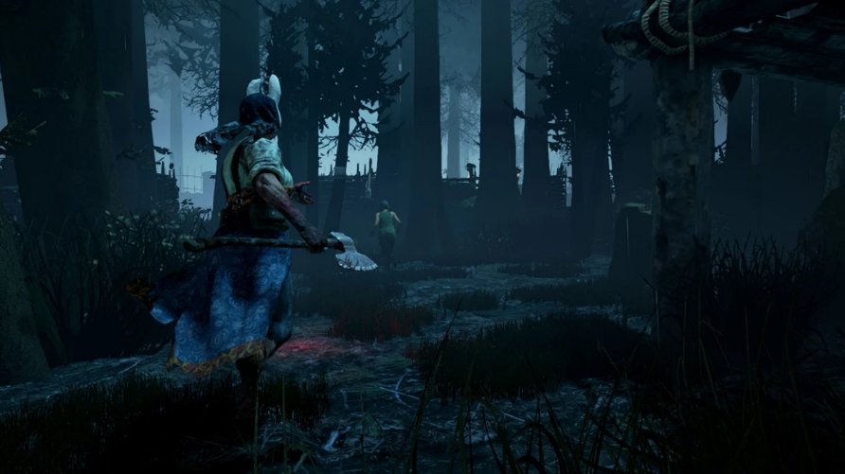

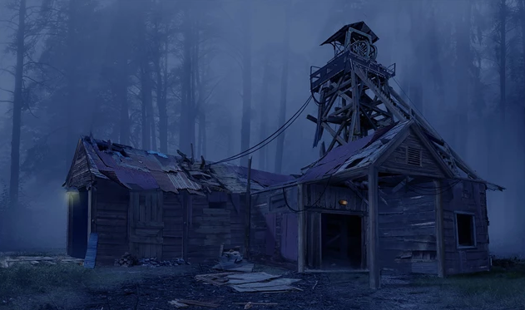

(*GGRecon*, n.d.)

# Game World

Minnesota Northwoods contains tall pine trees, lakes, tents, and cabins. Pine trees envelope the entire forest. Five lakes are scattered around the map. There are 100-200 tents and 100-200 cabins. Either they are in pristine or terrible condition. Occasionally, dirt trails facilitate navigation. Isolation and dread are promoted by the absence of human life. Besides hunters, every human is dead. Wendigos have the most power. Bears, wolves, and deer are prevalent.

# Mechanics

Players walk, run, jump, and climb. Louder breath, slowness, and the stop animation indicate stamina. They sneak around by slowly moving through environmental obstacles. Pounce then attack is the most aggressive playstyle. When players are hurt, their strength and speed decrease based on their health amount. Painful screams may alert foes. Headphone users experience directional sounds. Forest ambience mask quiet footsteps but not loud noises. Crickets and wind are sound ambience.

Wendigos are strong, fast, and rely on heightened senses. They can hear and see better than hunters. For sustenance, wendigos track animals to grab and devour. When they stand near lakes, they drink water. Cold regions heal and provide a small defense to wendigos. Tress are swingable weapons. If near a hunter, they snatch them. Wendigos crush hunters who cannot escape. Their sound and light sensitivity allows easier prey detection. Echolocation detects prey through sound. If hunters stab wendigos’ eyes, they must rely on their echolocation ability for navigation. Wendigos temporarily stun hunters with a loud roar. They must be near hunters to successfully perform abilities. Each ability has a 5-minute cooldown. Wendigos may clear pathways and scare hunters. They grab and tear to destroy fortifications.

Hunters are nimble resource users. They may climb wendigos to stab their eyes. If wendigos grab hunters, they struggle to escape. Successful escape allow hunters to live with unpredictable injuries. Escape failure slaughter hunters. Edible food, clean water, and medical supplies are necessary for hunters’ survival. Poisonous, rotten, and dirty substances cause 5 damage per 15 seconds over 2 minutes. Trial-and-error and journal entries assist in proper berry identification. Bandages heal 2 health per second over 5 seconds. When hunters are not at maximum strength and speed, pain killers increase these stats by 10% every 10 seconds. During bandage and painkiller use, other items are unusable. Machetes slice and decapitate creatures. Baseball bats stun and squash opponents. Hammer and nails fortify cabins. Knives stab enemies, cut flesh, and open canned food. Axes chop trees, destroy wooden barriers, and slay opponents. Two-handed axes slow hunters. If adequate materials are in the hunters’ inventory, they can upgrade weapons and tools. Lanterns and torches produce fiery light. Object sounds may alert wendigos. Lights assist hunter navigation. Fire damages wendigos by 20 health per five seconds. Traps stun and slow foes. Hunters rob journals from NPCs and cabins. Notes surround the world. Digital voice recorders can be found to record screams. Recordings may lure wendigos towards fire and traps. Hunters travel by foot, bike, or car. Although the slowest method is by foot, it is the quietest. Bikes are slightly faster but louder. Cars are the fastest but produce noticeable light and sound.

# Story Progression

Another hunter knocks the hunter player unconscious. Next, the hunter player is shoved outside the 1970s-styled black car. The NPC hunter shouts, “Have fun!”, drives away then disappears in a supernatural manner. Before the hunter can stand, the camera is pointed at the wendigo’s side. The wendigo holds onto a tree with a red glowing eye. It arches its head up then roars until the environment vibrates. Seconds later, the hunter is in the camera view. The hunter asks, “Where’s my rifle?” as they search for it. After the hunter sighs, players start gameplay.

The story’s middle section is gameplay dependent. Wendigos and hunters may explore the forest to uncover environmental narrative. Hunters scavenge bodies to reveal ID cards, outfits, and clues to defeat wendigos. ID cards and outfits give NPCs personality. Body wounds indicate unnatural death. Journals contain long descriptions of NPCs and the world. Notes contain written and visual informational bits.

If wendigos slaughter hunters, they emit a victory roar. Wendigos stroll deeper into the woods. If hunters execute wendigos, night becomes day. Hunters escape the forest on foot.

# Character Descriptions

## Hunter

Hunters appear to be in their early 20s. They vary in height, weight, and color. Survival, loot, and combat are vital to win. Lore discovery is optional.

## Wendigo

Wendigos have long antlers and red glowing eyes. Their faces are long and thin. Black fur and emaciation clearly define their bodies. Wendigos have sharp teeth and claws. Their body structure is that of a bipedal deer. Survival and combat are essential to win.

## NPC Civilian

Civilians have diverse appearances. They are more common than military. However, little supplies can be stolen from them. Food is edible or rotten. Water is clean or dirty. Usually, weapons and tools are weaker. Clothing indicates civilian occupation. If the NPC is a normal civilian, they carry a bit of everything. Hunters possess more food, water, and traps. Better weapons are more likely to be found. Medical staff carry bandages and painkillers.

## NPC Military

Military wear the same outfit with different hair and skin. Although rarer to find, they carry more supplies. Weapons and tools are more durable. Their weapons are more powerful.

# User Interface

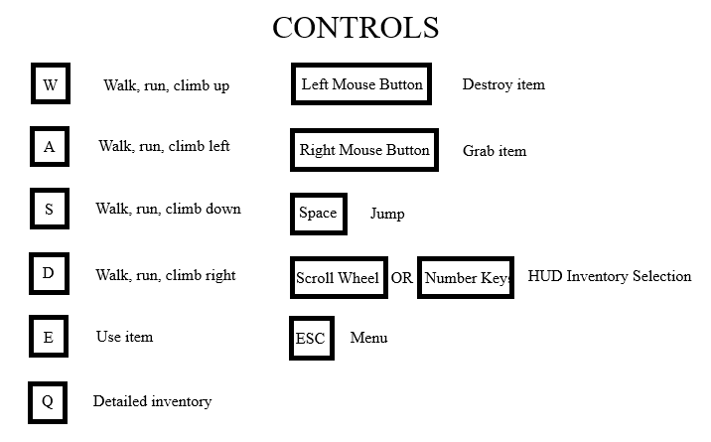

Double tap W to run. Players can dodge in a direction by double tapping A, S, or D. The detailed inventory shows items that can be dragged into the HUD inventory. Before item use, it must be in the HUD inventory. Point to an item then hold the left mouse button to destroy items. After Hover over an item then click the right mouse button to grab it. ESC title screen menu includes new game, resume, and quit options.

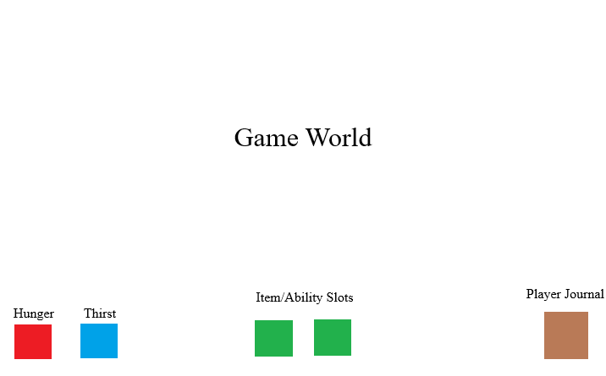

Health decrease is visualized by full screen crimson red opacity. More opacity equals lower health. Cold is represented by more opacity equals colder. Instead of red, the screen becomes icy blue. Hunger and thirst are indicated by small icons. When the player is hungry or thirsty, icon bars decrease. Two inventory slots represent the hunter’s left and right hands. For wendigos, these slots are abilities. Journals document acquired lore objects and custom notes. Wendigos do not have journals.

# Platform

Windows is the most common PC gaming platform. Keyboard and mouse provide more accuracy than console.

# Project Management

## Team

1. Designers
   1. Kaitlyn Moeller
   2. Generic Member
2. Programmers
   1. Generic Member
   2. Generic Member
3. Artists
   1. Generic Member
   2. Generic Member
4. Sound Designer
   1. Generic Member

## Budget

|  |  |  |
| --- | --- | --- |
| Team Member | Budget | Notes (if any) |
| Kaitlyn Moeller and Generic Member | $36,020/year * 2 years development time * 2 people = $144,080 | This is calculated by the average game designer salary in Arizona. The number is based on ZipRecruiter. |
| 2 Generic Members | $99,370/year * 2 years development time * 2 people = $397,480 | This is calculated by the average game programmer salary in Arizona. The number is based on ZipRecruiter. |
| 2 Generic Members | $ 97,940/year * 2 years development time * 2 people = $391,760 | This is calculated by the average game artist salary in Arizona. The number is based on ZipRecruiter. |
| Generic Member | $39,070/year * 2 years development time = $78,140 total | This is calculated by the average game sound designer salary in Arizona. The number is based on ZipRecruiter. |

## Schedule

|  |  |  |
| --- | --- | --- |
| Milestone # | Timeframe | Deliverables |
| 001  (Year 1) | January 1st – March 1st | Concept and pre-production complete |
| 002  (Year 1) | March 1st – June 1st | Complete implementation of objects, characters, and backgrounds |
| 003  (Year 1) | June 1st – September 1st | Complete programming/scripting of animations, physics, logic, progression, and math |
| 004  (Year 1) | September 1st – December 1st | Complete implementation of sound |
| 005  (Year 2) | January 1st – March 1st | Released alpha version, gather user feedback, and discuss how to move forward with game development |
| 006  (Year 2) | March 1st – June 1st | Tune gameplay, fix logic errors, and remove programming bugs |
| 007  (Year 2) | June 1st – September 1st | Released beta version, gather user feedback, and prepare game for gold master release |
| 008  (Year 2) | September 1st – December 1st | Released highly polished gold master version |

References

[Images of Dead by Deadlight game]. (n.d.). GGRecon. <https://www.ggrecon.com/guides/dead-by-daylight-maps/>

[Image of Sam and Dean in hunter gear]. (n.d.). The Millennial Gentleman. <https://millennialgentleman.com/2020/10/how-to-dress-like-sam-and-dean-winchester/>

Samuelson, D. (2019). Wendigo [Drawing]. Inprnt. <https://www.inprnt.com/discover/image/dillonsamuelson/wendigo>

Williams, J. (n.d.). Computer horror-game demographics: 57 stats [2023]. Techpenny. <https://techpenny.com/horror-game-demographics/#Age_Demographics_of_Horror_Game_Players>